ELOCKER Telltale – CGEA1.3

Functional Description

The purpose of the Elocker Telltale is to inform the driver the Electronic Locking Differential is engaged.

The Elocker Telltale correlates the RearDiffLckLamp_D_Rq signal, and the Operational_Mode to illuminate or extinguish the Elocker Telltale.

The Elocker Telltale shall provide an iconic representation that will illuminate or extinguish to inform the driver whether or not the Electronic Locking Differential is engaged.

Interfaces

Interface Context Diagram (I/O Block Diagram)

- Elocker Telltale Indication

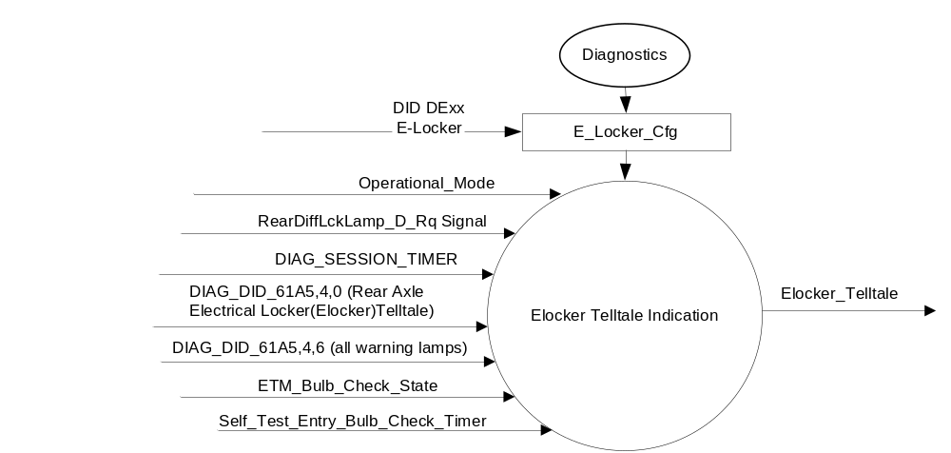

Inputs

      - INTERNAL:
            - DIAG_SESSION_TIMER
            - Operational_Mode
            - DIAG_DID_61A5,4,6 (all warning lamps)
            - DIAG_DID_61A5,4,0 (Rear Axle Electrical Locker (Elocker) Telltale)
            - ETM_Bulb_Check_State
            - Self_Test_Entry_Bulb_Check_Timer

      - MUX message on the CAN Bus from TCCM

- RearDiffLckLamp_D_Rq Signal

Signal Name | Size  (bits) | Detail | Units | Res. | Offset | State Encoded | Min. | Max.
RearDiffLckLamp_D_Rq | 2 |  | SED | 1 | 0 |  | 0(0x0) | 3(0x3)
 |  | OFF |  |  |  | 0x0
 |  | ON |  |  |  | 0x1
 |  | Flash |  |  |  | 0x2
 |  | Not Used |  |  |  | 0x3

Outputs
Elocker_Telltale, which is used to control the state of the LED

Function/Performance

Operational Modes

Mode | Differentiating Vehicle Conditions
Sleep Mode | Elocker Telltale OFF
Limited Mode | Elocker Telltale OFF
Normal Mode | Elocker Telltale ON/OFF
Crank Mode | Elocker Telltale ON/OFF

Voltage Levels

Refer to the Cluster Features table located in the Operational Modes and Voltage Range Strategies Section in this SPSS

Human-Machine Interface

Visual

Indicator Graphics / Display Format

For actual symbol definition refer to database # I.195 of the 03-0685 ARL requirement.

Indicator Color Coordinates
Amber - Reference SDS IL-0017/IS-0379

Indicator Characteristics
LED – Elocker Telltale

Audio

None.

System Accuracy

The Elocker_Telltale shall change the state of the Telltale within 100msec of a state change as indicated in the state matrix reference 1.3.5.1 Subsystem Algorithm Flowchart/ State Diagram.

Operation: Performance and Functional

Subsystem Algorithm Flowchart / State Diagram

Figure 1.1 E-Locker Telltale Diagnostic Configuration Flowchart

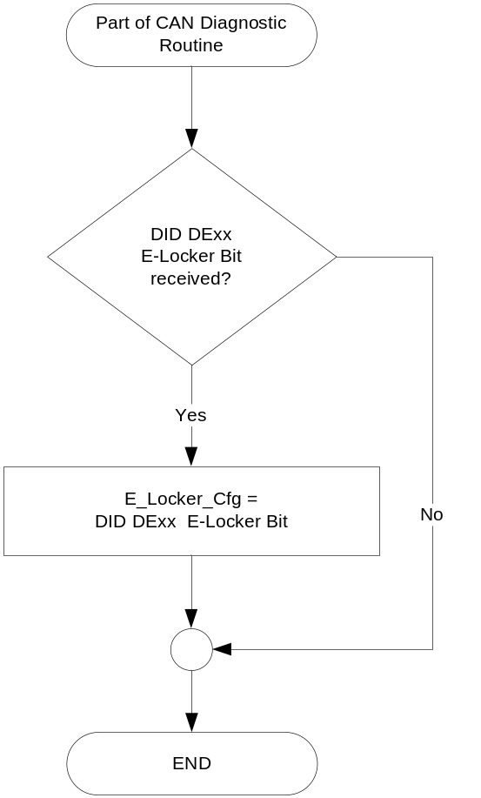

- State Matrix for Elocker Telltale

Operational_Mode | E_Locker_Cfg | ETM Bulb_  Check_State | DIAG_  SESSION  _TIMER | Self_Test_ Entry_Bulb_ Check_Timer | DIAG_DID_61A5,4,0 (Rear Axle Electrical Locker (Elocker) Telltale) | DIAG_DID_  61A5,4,6  (all warning  lamps) | RearDiffLckLamp_D_Rq Signal | Elocker_  Telltale
Normal or  Crank | enabled | X | Not Active | X | X | X | On (0x1) | ON
Normal or  Crank | enabled | OFF (0x0) | Not Active | X | X | X | Missing as per 1.4.1 | OFF
Normal or  Crank | enabled | X | Active | X | Not Received | Not Received | On (0x1) | ON
Normal or  Crank | enabled | X | Active | X | ON (0x1) | X | X | ON
Normal or  Crank | enabled | X | Active | X | X | ON (0x1) | X | ON
Normal or  Crank | enabled | X | Active | Active | X | X | X | ON
Normal or  Crank | enabled | ON (0x1) | Not Active | X | X | X | X | ON
All Other Cases |  |  |  |  |  |  |  | OFF

X = Don’t Care
Not Received = The state when a DIAG_SESSION_TIMER is active and the DID has not been received

Operation Description (supports algorithm flowchart /state diagram)

Function Safety Classification (EMC)
Class B

Memory Storage

Parameter Name | Description | Value at  Battery Connect | Value at  Module Wake-up
E_Locker_Cfg | State indicator for feature presence controlled via CAN at EOL at VO plant. | Use Stored Value | Use Stored Value
Elocker_Telltale | Used to control the state of the LED | OFF (0x0) | OFF (0x0)
RearDiffLckLamp_D_Rq Signal | CAN signal sent from TCCM. | OFF (0x0) | OFF (0x0)
DIAG_DID_61A5,4,0 (Rear Axle Electrical Locker (Elocker)Telltale) | Warning Lamp status 2, byte 4, bit 0 (Rear Axle Electrical Locker (Elocker) Telltale) | 0 (0x0) | 0 (0x0)
DIAG_DID_61A5,4,6 (all warning lamps) | Warning Lamp status 2, byte 4, bit 6 (all warning lamps) | 0 (0x0) | 0 (0x0)
ETM_Bulb_Check_State | State indicator for warning bulb in ETM | OFF (0x0) | OFF (0x0)
Operational_Mode | 4 state indicator for cluster operational mode | Limited | Limited, Normal or Crank

Timer Name | Description | Value at  Battery Connect | Value at  Module Wake-up
DIAG_SESSION_TIMER | Timer used to time-out a diagnostic session | Not Active | Not Active
Self_Test_Entry_Bulb_Check_ Timer | Timer used in diagnostic session to do a self check of telltales | Not Active | Not Active

Prove Out

No

Reconfigurable Telltale

No.

Message Center Msg

None

Error Handling

Missing Message Strategy

The signals will be declared missing as per the Diagnostics section of this SPSS.

DTCs states and history will be determined as per the Diagnostics section of this SPSS.

If the E_Locker_Cfg is set to disabled, the cluster shall never log a missing message DTC due to this feature.
.

Diagnostics

Self Test

Bulb illuminated during self test as per Self_Entry_Bulb_Check_Timer

Engineering Test Mode

Reference section “Dealer / Engineering Test Mode (ETM)”.

Part II Performance

Supported Diagnostic DIDs (Service $22 and $2F)
Number | DID / CommonID Name | DID Type
0x61A5 | Warning Lamp status 2, byte 4, bit 0 (Rear Axle Electrical Locker (Elocker) Telltale) | Bit Mapped
0x61A5 | Warning Lamp status 2, byte 4, bit 6 (all warning lamps) | Bit Mapped

Supported Diagnostic Trouble Codes (DTCs)

DTCs shall be logged as per the diagnostic section of this SPSS.

DTC | Description
C10200 | Lost Communication with Transfer Case Control Module

DID DExx

Block  Num | Block Description | Byte(s) | Bits | State: Description | "0" | "1" | Default | Comments/  Information
PACKETED BLOCKS
xx | Option Content (B&A) | * | * | E-Locker | Disabled | Enabled | Disabled
*Byte and bit location to be identified in Part II Specification for this cluster

Reference Specification

IS-0001 WARNINGS/INDICATORS/DISPLAYS PROVEOUT
IS-0046 INSTRUMENTATION MATERIAL RESISTANCE TO CLEANING
IS-0052 OPERATING VOLTAGES - FUNCTIONAL/PERFORMANCE
IS-0069 FUNCTIONAL IMPORTANCE CLASS
IS-0324 WINDSHIELD & OTHER REFLECTIONS
IS-0327 WARNING INDICATOR EVALUATION
IS-0329 FLICKERING OF LAMPS
IS-0379 NORTH AMERICAN WARNINGS AND INDICATORS STRATEGY

IL-0017 TELLTALE AND INTERIOR ILLUMINATION COLOR
IL-0021 CRAFTSMANSHIP - DISPLAYS
IL-0023 CLARITY/LEGIBILITY/READABILITY
IL-0025 INTERIOR ILLUMINATION INTENSITY
IL -0027 VISUAL CONTRAST
IL -0043 OPERATIONAL ENVIRONMENT FUNCTIONALITY
IL -0045 COLOR
IL -0047 TELLTALE; INDICATOR AND DISPLAY LIGHT INTENSITY
IL -0048 ILLUMINATION ACCEPTABILITY

03-0661 PLACEMENT: CONTROL AND DISPLAY LOCATIONS
03-0662 PLACEMENT: LOGICAL GROUPING FUNCTION AND USAGE
03-0664 PLACEMENT: DOWN VISION TO COMPONENTS WITH HIGH VISUAL DEMAND
03-0665 PLACEMENT: EXPECTED LOCATIONS OF CONTROLS AND DISPLAYS VDS
03-0670 INTERIOR VISIBILITY
03-0671 INTERIOR VISIBILITY: REFLECTIONS FROM COMPONENTS & SURFACES
03-0672 INTERIOR VISIBILITY: REFLECTIONS IN DISPLAYS
03-0673 INTERIOR VISIBILITY: VISUAL OBSCURATIONS
03-0674 INTERIOR VISIBILITY: ILLUMINATION CONTROLS / DISPLAYS
03-0675 INTERIOR VISIBILITY: VEILING GLARE
03-0677 INTERIOR VISIBILITY: SUNLIGHT WASHOUT
03-0681 IDENTIFICATION: CHARACTER AND SYMBOL SIZE
03-0682 IDENTIFICATION: LEGIBILITY
03-0685 IDENTIFICATION: SYMBOLS, ABBREV FOR CONTROL
03-0721 LOGIC OF OPERATION: OPERATIONAL STEREOTYPES
03-0722 LOGIC OF OPERATION: INTERPRETATION
03-0723 LOGIC OF OPERATION: USE OF SYSTEMS WITH VISUAL DISPLAYS

Revision History

SPSS Module Revision History

Revision Level | Name | Change Description | Date
1.0 | V. Patel | Updated for CGEA 1.3 based on CGEA STSS v1.0  Section 1.2.2 – Deleted table referencing the HS-CAN message that contains the input signal. Deleted “ID” and “POS” columns from table 1.0  Section 1.3.5.1 – Added row for missing message action in table 1.1  Section 1.4 – Rewritten. Deleted references of specific missing message flags and timer.  Section 1.5.3 – Deleted DTC logging criteria from table. | 3/26/2010
1.1 | JBlatchf | Added Rear Axle Electrical Locker (Elocker) Telltale DID information.  Figure 1: Added standard telltale inputs.  1.2.2: Updated with DID information.  Table 1.2 Updated with DID information corrected typo on output.  1.3.5.4: Updated with DID information  1.5.3: Added DID information. | 6/22/12
1.2 | S. Watkins  M. Hakim | Section 1.2.1: Interface Context Diagram:  Updated the configuration DID number from “00” to “xx” to accommodate the extended number of configuration DIDs  Section 1.3.5.1:  Added Figure 1.1 E-Locker Telltale Diagnostic Configuration Flowchart  Section 1.3.5.2: Removed listing the specific CAN bus for the CAN signal.  Section 1.3.5.4: Memory Storage: Added E_Locker_Cfg parameter to the table.  Separated the timers in a separate table.  Section 1.5.3: Part II Performance:  Added DID DExx table.  Updated document footer. | 8/9/2013

